Assignment 4

Name – Abhishek Agrahari

Roll Number 190123066

**Question 1**

This distribution is a beta distribution with α1 = 2 and α2 = 4. So smallest value possible c is f((α1-1)/ (α1 + α2 - 2)) which is 2.109375.

(a) Average iteration needed to generate a random number would be c which is 2.109375. This is because probability of acceptance is 1/c, so on an average c number of trials are needed to get 1 accepted random number.

(b) Sample mean = 0.33218115767

Expectation of the PDF can be calculated by integrating x*f(x) from 0 to 1 which comes to be 1/3 in this case. This value is very close to the sample mean.

(c) P (0.25 <= X <= 0.75) from the generated sample is 0.6184

Exact value of probability can be calculated by integrating f(x) from 0.25 to 0.75 which is 0.617188 in this case. This value is very close to the probability calculated from the generated sample.

(d) Average iterations required to generate a random variable from the generated sample is 2.1281 which is comparable to theoretical value obtained in first part of 2.109375.

(e)

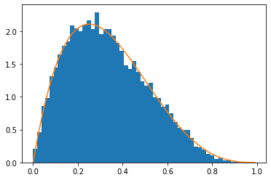

(f) Taking c = 3,

a) As explained in 1(a) part it should be c which is 3 in this case.

b) Sample mean = 0.33203779401

Expectation of the f = 1/3. This value is very close to the sample mean.

c) P (0.25 <= X <= 0.75) from the generated sample is 0.6184

Exact Probability = 0.617188

d) Average iterations required to generate a random variable from the generated sample is 2.9976 which is comparable to theoretical value obtained in first part of 3.

e)

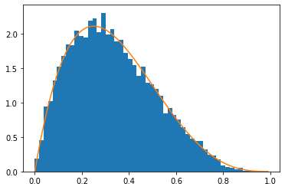

Taking c = 4

a) As explained in 1(a) part it should be c which is 4 in this case.

b) Sample mean = 0.33186951688

Expectation of the f = 1/3. This value is very close to the sample mean.

c) P (0.25 <= X <= 0.75) from the generated sample is 0.6162

Exact Probability = 0.617188

d) Average iterations required to generate a random variable from the generated sample is 4.0214 which is comparable to theoretical value obtained in first part of 4.

e)

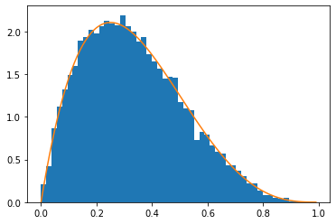

Question 2:

f(x) proportional to (x^(a-1)) *(e^(-x))

For f(x) to be valid PDF, integral from 0 to 1 should be 1, which gives proportionality constant to be 1/γ where γ = $\int_{0}^{1}{x^{a-1}ⅇ^{-x}ⅆx}$ .

Now, taking g(x) = $ax^{a-1}$ and c = 1/(γ*a) gives f(x) <= c*g(x).

Now, taking a = 0.7, γ comes out to be 0.988064. Therefore c = 1/ (γ* a) = 1.44582 and g(x) = 0.7*x^(-0.3).

Rejection Constant ( c ) = 1.44582

Dominating PDF (g(x)) = 0.7*x^(-0.3).

